School Uniform 2022

Uniform must be clearly marked with the girl’s name. Uniform can be purchased via the uniform shop at John Lewis or by order and collection in store at Peter Jones, Sloane Square, SW1 8EL, and the PE uniform by order from SWI. Some other items can be obtained from any supplier. The parents’ association The Grey Coat Guild holds second hand uniform sales which are a more affordable way of obtaining the uniform. These take place on the Admissions Day for Year 7 and at other times of the year for other Year groups. The school uniform policy is strictly enforced. Any inappropriate items will be confiscated, and can be redeemed from the school office at the end of the half term.

Uniform from Peter Jones/John Lewis www.johnlewis.com/browse/baby-child/grey-coat-hospital-school-girls-winter-uniform/_/N-lvd6

Compulsory:
- Skirt* Two official styles of knee length skirt may be worn, box-pleated, or pleated.
- Blouse* A patterned short or long-sleeved school blouse in blue or green
- Blazer* Grey with GCH badge or the school crest. The blazer is a compulsory part of the uniform and must be worn to and from school every day.

Optional:
- Jumper Plain grey classic V-neck jumper or cardigan.
- Summer dress

Optional Uniform from Marks and Spencer
www.marksandspencer.com/2-pack-girls-slim-leg-trousers/p/clp60450795?color=BLACK#intid=carousel_FUNH_AT_PHOENIX-SIMILAR_TOP_PDP_16_13:b068426d-afde-4f1f-a1b0-5a3a8db11397

- Trousers, grey, in a two pack

From any supplier:

- Socks/tights Plain grey, white or black socks or tights. No patterned tights or leg warmers may be worn and tights and socks cannot be worn together.

- Shoes Plain black, leather low-heeled walking shoes in a lace-up or strap style. No patterned or mixed colour footwear is allowed. No boots are allowed, nor shoes above the ankle (i.e. Kickers). Platform or flatform shoes, canvas or trainer-type shoes are not acceptable.

- T-shirt (optional) A round-necked T-shirt may be worn under the blouse provided it is plain white with no pattern or colour trimming.

- Coat To be worn in very cold or wet weather over the blazer. Any plain black or a plain grey coat without any pattern, writing or logos.

- Scarf/Hat/Gloves (optional) plain grey, navy blue, black or white.

PE Uniform from SWI www.swischoolwear.co.uk/

- Sweatshirt (optional) - Grey sweatshirt with the school logo may be worn instead of a jumper or cardigan. Year 11 are allowed to wear navy blue sweatshirts.
- Jogging bottoms with school logo
- Black Cycling Shorts from SWI with school logo,

From any supplier

- Short sleeved White Polo Shirt
- Training Shoes must be mainly white with white laces.
- Socks White or grey socks.
- Plain Black Leotard for gymnastics or dance
- Leggings Plain black leggings may be worn for gymnastics or dance.

Other items
Science and Art Overall An adult-sized old shirt is ideal, or a traditional Science overall can be obtained from the Guild sales.

School Bag A sensible strong bag (not a plastic carrier bag) must be provided for books and equipment. A small rucksack is recommended because it balances the weight on both shoulders.

Jewellery and Make-Up
Rings, and any other form of jewellery, nail varnish or make-up may not be worn whether in school, or on the way to and from school, while wearing school uniform. Acrylic nails are strictly forbidden for health & safety reasons. However, the following items are permitted:

Wrist watch (optional) analogue and digital watches to be clearly marked with the girl’s name. Smart watches will be subject to mobile phone conditions, see below.

Earrings (optional) Only small 5mm plain small gold or silver studs, which may be bought from the Hospital, may be worn; one in each ear. Cross & chain (optional) or Crucifix & chain (optional). These may be worn provided they are not on display. No nose rings or tongue piercings. No other jewellery. No slogan wristbands, friendship bands etc and no decorated keyrings may be worn.

Eyebrows Slits in eyebrows are not allowed.

Hair Any hair colouring must be natural and not two tone.

Hair Accessories (optional) Practical items like hair grips may be worn provided they are plain, either in white, black, grey or navy blue. Oversized or decorative hair accessories will be removed/confiscated. A plain black, white, or grey headscarf may be worn for religious reasons. Ribbons and large headbands are strictly forbidden.

Mobile Phones
Both for educational and health and safety reasons we do not recommend that students bring mobile phones to school. However, if parents wish their daughters to carry a mobile phone it is permitted on the understanding that it must be kept switched off and out of sight at all times during the school day and afterwards when on the school site. If this rule is not adhered to the phone will be confiscated for five school days, after which students can redeem them on payment of 50p.

School uniform which must be purchased from John Lewis
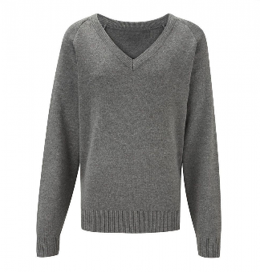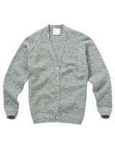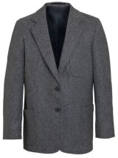
Optional Compulsory
Grey V-Neck or Cardigan (or Grey Wool Blazer
Sweatshirt from SWI may be worn instead)*
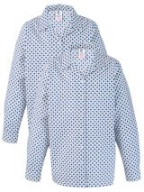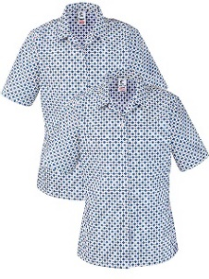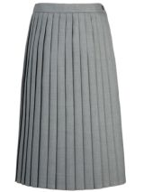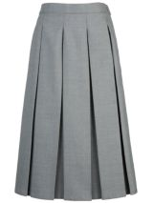
Compulsory Compulsory
Blouse, Pack Of 2 Pleated Skirt or Box Pleat Skirt
or Short sleeved (or grey M&S trousers, see over)

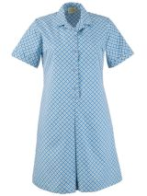
Optional
Summer Dress

School uniform which must be purchased from Marks & Spencer:

Grey Trousers 2pk Girls’ Slim
Product code: T761425 ONLY

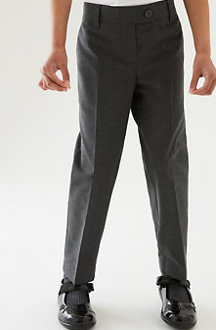
Optional

PE Kit which must be purchased from SWI
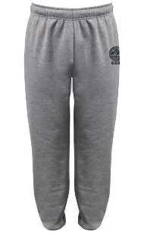 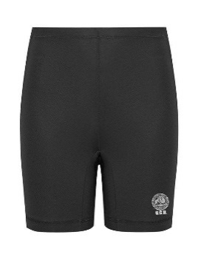 * 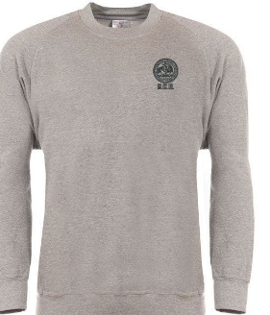
Compulsory Compulsory Optional
Jog Pants Tech Fit Shorts Sweatshirt

Items from any supplier:
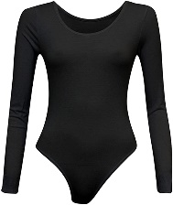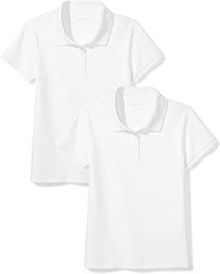
Compulsory Compulsory
Black leotard White polo shirt

