A Level Drama and Theatre
Hi everyone, 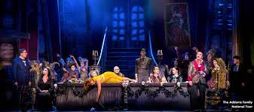
We are so pleased that you are looking at our transition activities with a view to taking A Level Drama and Theatre next year. We have tried to offer a range of tasks to give you a sense of how broad the subject can be, how exciting the possibilities are, and to whet your appetites for further study.

There is a lot of online theatre available at the moment, so you definitely need to be sampling that! There are a few recommendations here, but the NTLive library is also available with the access code provided in the Small Island task.

Plans for next year include working with Paper Birds and participating in Masterclass with The Theatre Royal, Haymarket, and well as visits from theatre practitioners and … we hope …some theatre trips!

Meanwhile, if you have any questions or requests, please email lcunningham@gch.org.uk

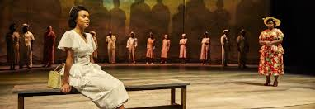

Year 11 progression to Key Stage 5
Resources to help you prepare for post 16 study in Drama and Theatre:

Listen to these Podcasts from the Royal Court’s Playwright Podcasts introduced and presented by Simon Stephens.
[There is a podcast from Alecky Blythe (see Box 6) in S2 Ep13!)
https://royalcourttheatre.com/series/playwrights-podcast/

Craft your own scale model version of the Royal Albert Hall. Use the puppets to bring the stage to life. This is just a fun creative, craft task to get you thinking about staging.
https://www.royalalberthall.com/about-thehall/news/2020/april/buildyour-own-royal-albert-hallpuppet-theatre/

Read this article about the evolution of modern theatrical production.
https://www.britannica.com/art/theater-building/The-evolution-ofmodern-theatrical-production

Watch this Physical Theatre from Gecko Theatre. Gecko is an award-winning and internationally acclaimed physical theatre company based in Ipswich, led by Artistic Director Amit Lahav. Gecko’s shows are visual, visceral and ambitious crafted to inspire, move and entertain.
https://www.youtube.com/playlist?list=PLMqUl4Vvxqq0sxMaAfyWQTupL9es_K1r

Complete this task to unleash your neutral mask. All you need is an empty cereal box. Listen to leading practitioner Annie Sutton guide you through the process.
https://www.youtube.com/watch?v=NUP1116lKwM&feature=youtu.be

Listen to this interview with Alecky Blythe. An exceptional Verbatim Theatre playwright. She explains how she crafts her plays.
Read the news article about her play ‘London Road’
https://www.youtube.com/watch?v=u21hmi7O6xE
https://www.bbc.co.uk/news/entertainment-arts-17489109

Watch this TED talk from Selina Busby (Lecturer at The Royal Central School of Speech and Drama) discussing “Can theatre change the world?”
https://www.youtube.com/watch?v=r3rj5jB96no

Read this article about Forum Theatre (Theatre of the Oppressed) and then watch this Forum Theatre performance from student theatre group STATE of Reality.
https://www.culturematters.org.uk/index.php/arts/theatre/item/2455-the-theatre-of-theoppressed

https://www.youtube.com/watch?v=vcLcXeXJVDU

Complete this movement class led by Angela Towler who is a former rehearsal director at Rambert Dance Company.
Join in with the National Dance Company of Wales.
https://www.bbc.co.uk/iplayer/episode/l0026gtf/national-dancecompany-wales-morning-class

Listen to power of sound design. What is binaural sound? Could you use it in performance like the National Theatre have with their production of Anna?
https://www.youtube.com/watch?v=hFM4hPgGZuk

Create ‘What walls do you live within? Brought to you by Fourth Monkey Ensemble theatre. Get involved and creatively express yourself.
https://www.fourthmonkey.co.uk/wpcontent/uploads/2020/04/Fourth-Monkey-Create-Program2020.pdf

Watch the Royal Ballet’s version of ‘Metamorphosis’ recorded from the Royal Opera House.
This ballet is taken from the original play by Franz Kafka from 1915 and is often taught as a physical and surrealist piece of theatre.
https://www.youtube.com/watch?v=6H6KzBu4K68

Read a play a week with Nick Hern Books.
Download, read and then listen to Q&A podcast about the play of the week.
https://www.nickhernbooks.co.uk/playgroup

Get involved with ‘Windows to the world’ run by Kneehigh Theatre Company. A daily creative challenge will be uploaded at 9am every day.
https://www.kneehigh.co.uk/windows/

https://www.franticassembly.co.uk/frantic-digital
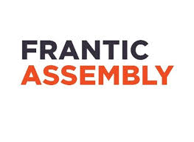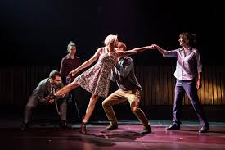

Find out about Frantic Assembly!

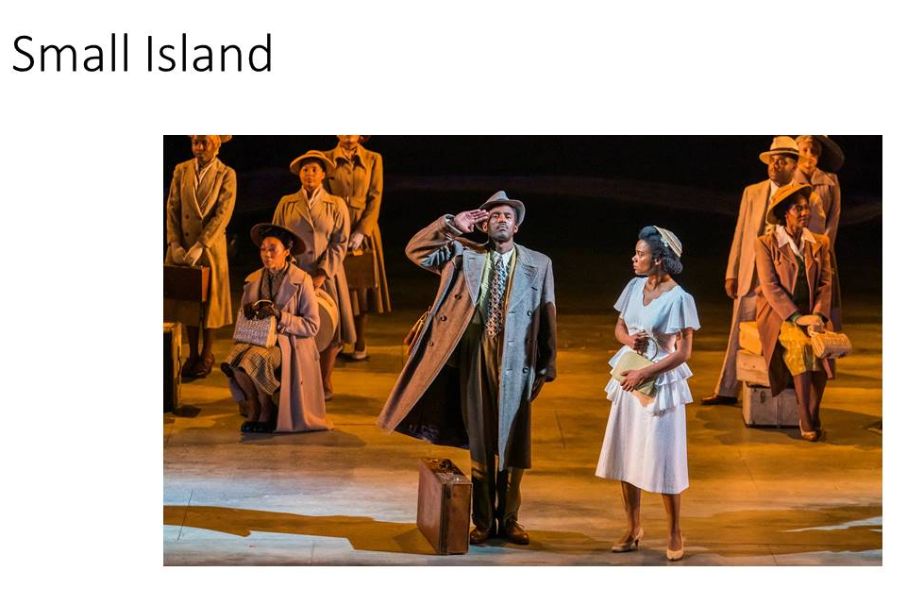
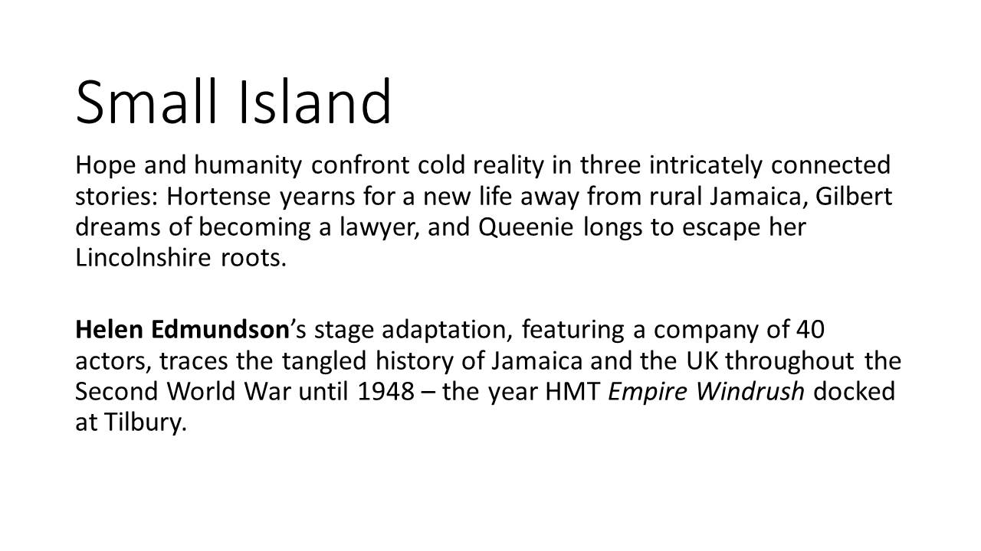
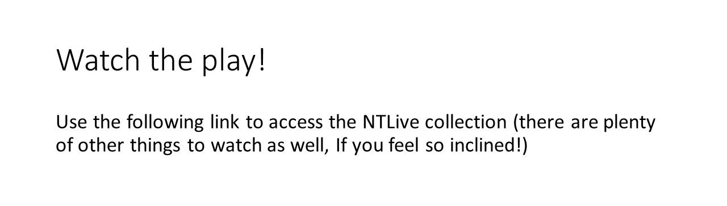
Your access details are:
https://www.dramaonlinelibrary.com/series/national-theatre-collection-iid-190464
Username: 5Tk$9Tt*
Password: 5Nx,3Kz.

Read this review from The Guardian. Watch the trailer!. Read the rehearsal diaries!

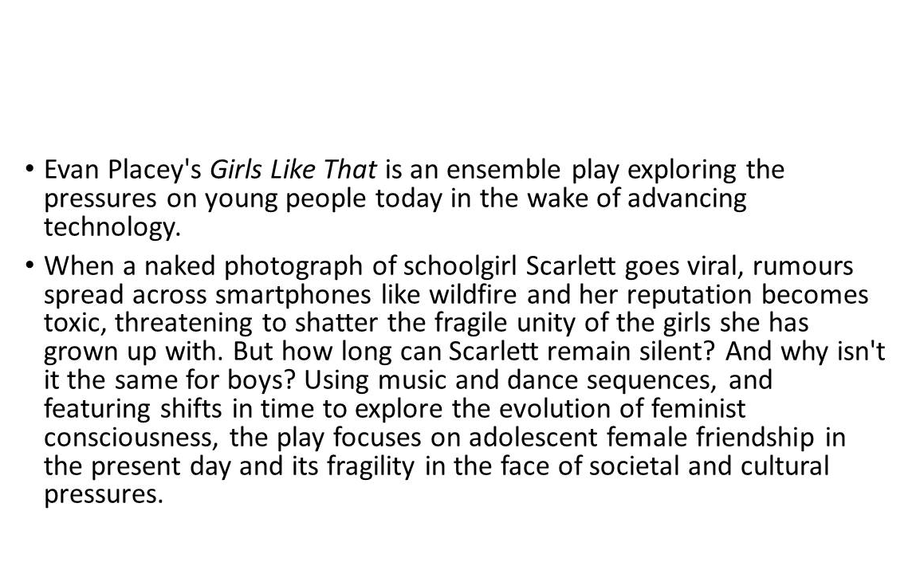

Watch it here:

- https://www.youtube.com/watch?v=Cx2KDNusk9E

See you in September!

