Sociology transition materials 2020

Sociology is the study of social life, social change, and the social causes and consequences of human behaviour. It is the study of human social relationships, culture and institutions. Sociologists investigate the structure of groups, organisations, and societies, and how people interact within these contexts.
Sociology’s subject matter is hugely diverse ranging from what causes people to get married, to what motivates an angry mob to beat someone up in the street; from what causes organized crime, to the formation of religious cults. We will study from how race, gender, nation and social class are socially constructed, to the narratives and processes underpinning the state and the economy.
Unifying the study of these diverse subjects of study is sociology’s purpose of understanding how human action and consciousness both shape and are shaped by surrounding cultural and social structures. Some will approach these as objectively and scientifically as possible whilst others will consciously be seeking to change the world.
This work book is designed to prepare you for studying A-level Sociology. As we don’t offer Sociology at GCSE at The Grey Coat Hospital so it is important that you arrive in September with a basic knowledge of sociological concepts and perspectives. I don’t mind if you complete the work as a word document, in writing or as an amended version of this document.

What is Sociology? Sociologists believe society is governed by social institutions that are either objectively ‘real’ in some sense, or simply exist in our own heads. Such as education, the family, the media, the criminal justice system, health and religion. These different parts work together and play an important role in shaping our lives. They also believe that every society has a culture, which means a way of life, and a set of norms (expected behaviours) and values (what we hold to be important).

How do we become a part of society? Sociologists argue that children go through a process called socialisation, which means learning society’s norms and values. At home, children go through primary socialisation, where they learn how to speak, share and other basic behaviours and norms. Secondary socialisation comes later, at school and beyond, where individuals learn from their peers and others.

Our behaviour is influenced by those around us – we are encouraged to conform to society’s expectations and norms (obey the rules and do what is expected) and discouraged from deviating from this. These expectations are enforced by sanctions from others – positive sanctions when we do the right thing, eg a smile, a laugh, or a reward, and negative sanctions when we do the wrong thing, a disapproving frown, a shake of the head, or a detention. The
way society encourages us to conform and discourages us from deviating is known as social control.

Task 1
Watch these 2 videos. Then answer the Questions.
Video 1: https://www.youtube.com/watch?v=bZYq_r4VXuA
This is the definition of sociology from the American Sociological Association.
Why did George and Sarah’s opportunities differ?
To what extent were George and Sarah ‘responsible’ for their choices?

Video 2: https://www.youtube.com/watch?v=YnCJU6PaCio

This is a cheerful little video from an American filmmaker called Nicole Sweeny that quite nicely explains what sort of subject Sociology is.

What does the presenter mean by seeing the general in the particular?

Can you think of any activities you engage in, things you do for fun, aspects of your personality, tastes in food or art, or attitudes and beliefs that might have something to do with your culture, gender, class, religion or national identity? How many of your ideas actually come from you?

What does she mean by seeing the strange in the familiar?

Can you come up with any examples of behaviours that you or your friends and family engage in that might seem pretty weird to someone unfamiliar with British life?

How might you describe a person’s social location? Could you draw a diagram that might depict the social location of a character in a book you have read or film you have seen?

What is marginalisation? Can you give an example of a marginalised group?

Our presenter says that there are many different kinds of power. Why does she say that? Can you think of 3 different kinds of power?

When studying sociology what do you think you will be more interested in studying small social situations like classrooms and family relationships or larger institutions like governments and religions?

TASK 2: find and write out the definitions of the following word in the introduction above, or
online.

Term | My definition
Sociology

Sociologist

Social institutions

Norms

Values

Sanctions

Primary socialisation

Secondary socialisation

Social control

Task 3
Take notes on ‘introduction to sociology Anthony Giddens and Philip Sutton’ (2017) Parts 1-3
Part 1 Part 2 Part 3
How to take notes:
Before answering the questions about these chapters, read them and make notes based on them. Then go back to the questions marked ‘Q’ and answer them.

You should put aside at least two hours to properly read and make notes about the chapter. The it is challenging and so you need to be methodical when you come across material you don’t understand. We do not expect that you will understand everything, but we do expect you to demonstrate that you have attempted to work through the ideas in the Chapter.
Do please email me if there is anything you do not understand.
aknifton@gch.org.uk

Step 1 – START SIMPLY
- Print the Chapter
- Take a pen/highlighter
- Quickly read the whole article
- Highlight/underline tricky words
- Look up and write down definitions on lined paper – be sure they actually make sense to you

Step 2 - BREAK IT DOWN
- Read one section at a time
- Write your own subtitle/summary for each paragraph or short section
- Rewrite or summarise sections in your own words on lined paper (IMPORTANT for revision)

Step 3 - TAKE WHAT YOU NEED
- Highlight phrases or quotations you could use in an exam
- Note Sociologist’s name or key words as research ‘pointers’ – i.e. what you’d next like to know more about
- Write down questions you want answered, however simple (THIS IS AN IMPORTANT DISCIPLINE!)
- Note examples that clarify an idea for you

Task 4

In Sociology, there are five main sociological perspectives (think of them as lenses
through which you study society):
1. Functionalists : these sociologists believe society runs smoothly, and is made up of
different parts which all work together to keep society stable. They believe people agree on
what is important (there is a value consensus) and people generally conform to the norms of
society. They tend to focus on the positive functions of different parts of society. Watch this
video to find out more: https://www.youtube.com/watch?v=-83vVeSC2_g
https://www.youtube.com/watch?v=wFgot8TJtmo

2. Marxists : based on the ideas of Karl Marx, they focus on inequalities based on social class
(how much or little money someone has). They believe this is the main inequality in society.
They argue there are two main classes: the working class (proletariat) and ruling class
(bourgeoisie) and believe the ruling class own and exploit the workers, treating them badly
and giving them low pay so they can make more money for themselves. Watch these videos
and find out more: https://www.youtube.com/watch?v=fSQgCy_iIcc
https://www.tutor2u.net/sociology/reference/sociological-theory-marxism

3. Feminists : see gender inequality, inequality between men and women, as the main
inequality in society. They argue women are treated badly and exploited by men, and that
society is patriarchal (male-dominated). Watch this videos to find out more:
https://www.youtube.com/watch?v=D6Dl-9pSW-4
https://www.tutor2u.net/sociology/reference/sociological-theory-feminism

4. Interactionism : Interactionists have a bottom up view of society. They think it arises from our actions in small groups rather than being a ‘thing’ that is out there causing our behaviour. Interactionists look at how society is preserved and created through repeated interactions between individuals. The interpretation process that occurs between interactions helps create and recreate meaning. It is the shared understanding and interpretations of meaning that affect the interaction between individuals. Individuals act on the premise of a shared understanding of meaning within their social context. Look at these videos to find out more:
https://www.youtube.com/watch?v=Ux2E6uhEVk0
https://www.youtube.com/watch?v=5U2XAJNazik&t=36s

5. Postmodernism : Postmodernism is an approach that attempts to define how society has progressed to an era beyond ‘modernity’ (from the industrial revolution until the 1960s). Within this era individuals are more likely to have a greater importance placed on science and rational thought as traditional metanarratives no longer provide a reasonable explanation for postmodern life. In addition, a postmodern society traditionally will have experienced globalisation which means new religions will be integrated into society. Therefore, society will be more likely to experience a ‘pick and mix’ culture when deciding a religion as individuals will choose a religion that best suits their lifestyle and choices. Look at this video to find out more:
https://www.youtube.com/watch?v=ZHBNTvlWczU
https://www.youtube.com/watch?v=0ZpF-IF9NzE

Summarise the theory and find an image online that you feel best sums up the theory

Perspective | Summary | Image
Functionalism

Feminism

Marxism

Interactionism

Postmodernism

Task 4
Is Britain fair?
Think about the videos you have watched… Two babies are born in the same hospital on the same day to different families. Do
they have an equal chance of…

… being healthy?
… going to university?
… getting a well-paid job?
… avoiding prison?
… succeeding in school?

- 1/3 of children in Britain live in poverty
- People born into the most deprived (poor) areas of the UK are likely to live, on average, 10
years less than those in affluent (well off) areas
- Only 30% of those receiving Free School Meals (FSM) (low family income) achieve a pass
in English and Maths at GCSE compared to 60% of those who do not receive FSM
- Only 7% of the population go to fee-paying schools, but they make up 42% of students at
Oxford and Cambridge and dominate top jobs in law, journalism, politics and health
- Last year, there was a 13% increase in food bank use
These statistics paint a bleak picture of whether or not Britain is a fair society. Before we
engage in the debate of whether or not Britain is fair, we must define what we mean by this.
A ‘fair’ society is a society where everyone has equality of opportunity – everyone has an equal
chance of achieving success and their background does not determine this. Sociologists call
this a ‘meritocracy’ – a society where status is based on merit (hard work and talent) rather than
the position you are born into. In a meritocracy, effort should be the only factor determining the
position someone gains in life.
Functionalists believe contemporary (modern) Britain is a meritocracy and that success is
determined only by hard work.

TASK 4: reflect on the statistics below. In your opinion, does everyone in Britain have an equal chance to succeed? Why or why not? (100 works)

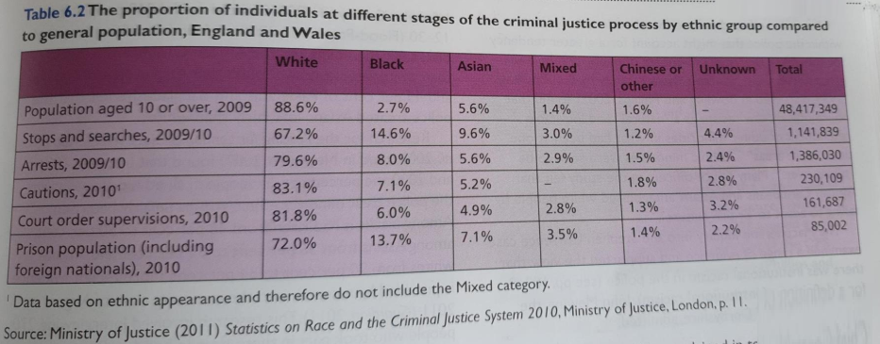
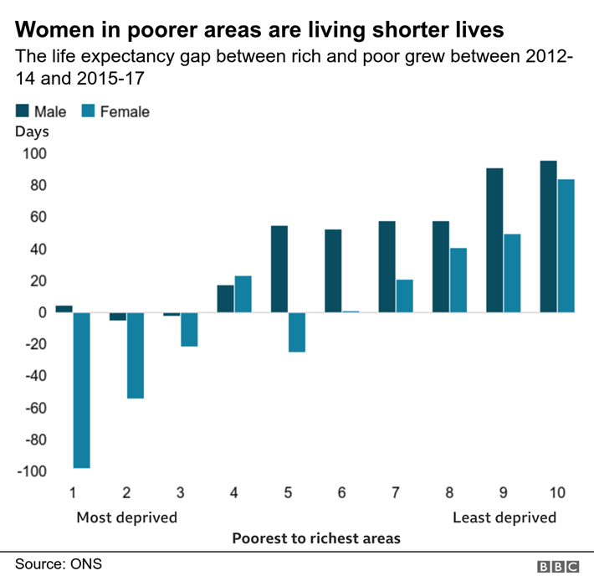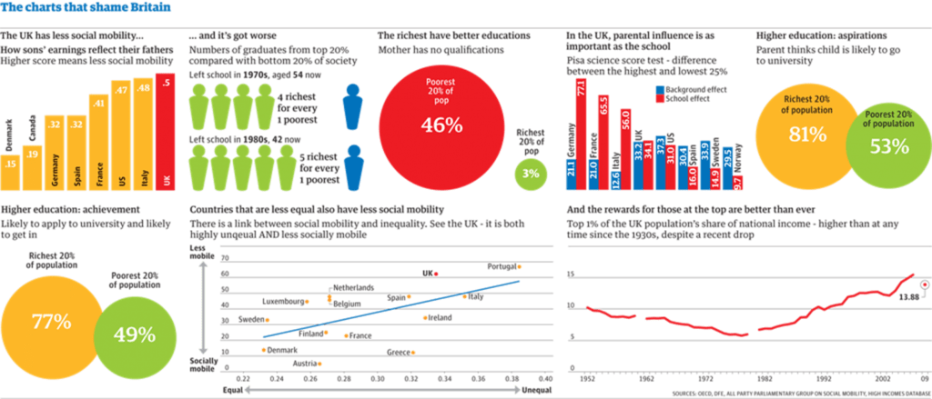
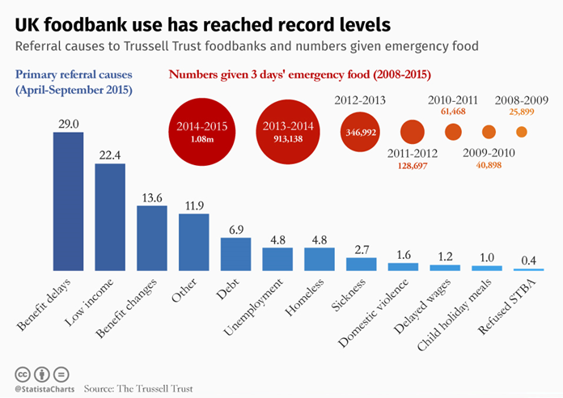
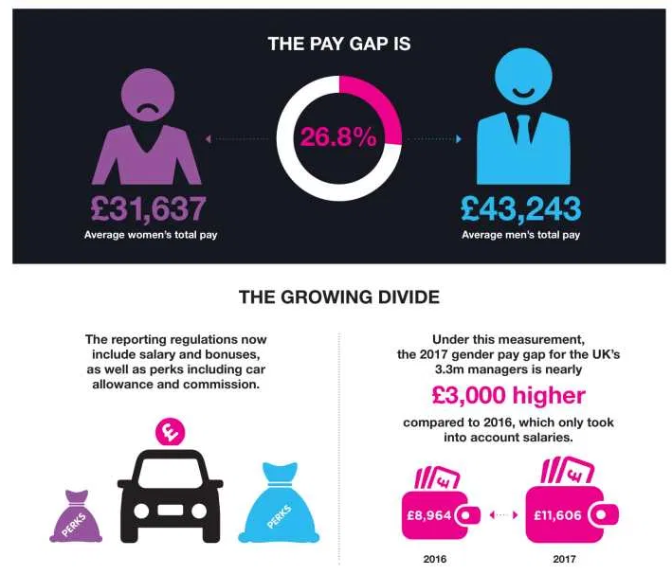

Unemployment (inactivity means economic inactivity)
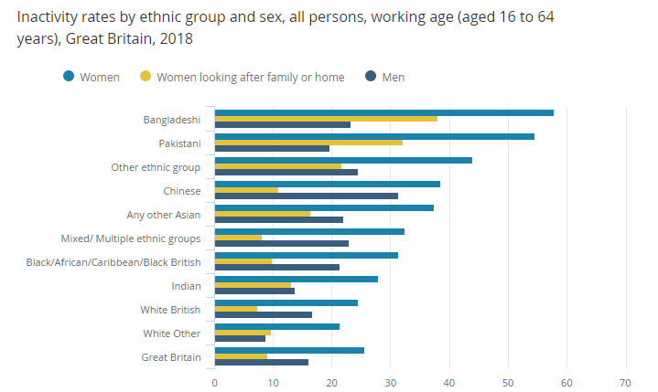

Task 5
In your first year you will be doing units on the Family and Education. I would like you to write 2 short essays of 500 words. I would like these essays to have 3 references to the journal articles I have provided and feature 2 different points of view and a personal conclusion.
Do please email me if there is anything you do not understand.
aknifton@gch.org.uk

Is education fair?
500 words
All of these articles talk about either different types of school or how being members of different groups in society effects your experience of school. Do you believe education in the UK is fair to its students?

Your essay will contain specific references to 3 of these articles. The best way to make a specific reference is to refer to an author by their second name.

Either follow the hyperlinks or go to
U drive/Transition work 2020/Sociology/Education
Louise Archer Gender, Class and Education 2009
John Williams Cultural capital 2020
Nicola Ingram Working Class Boys and Education 2010
Joan Garrod Job Aspirations 2018
Marsha Jones Grammar Schools 2017
Tina Rampino The Gender Education Gap 2015
Julian Salisbury Marxism and Education 2015
Emma Smith is School fair 2010
Joan Garrod Faith Schools 2015
Joan Garrod Cultural Capital 2017

Has family changed for the better since 1945?
500 words
All of these articles have something to do with how family has changed in recent years. Tell us what sorts of changes there have been and if you personally believe them to be positive or negative.
Your essay will contain specific references to 3 of these articles. The best way to make a specific reference is to refer to an author by their second name.

Either follow the hyperlinks or go to
U drive/Transition work 2020/Sociology/Family
Mary Daly Social Policy and the Family 2015
Joan Garrod Parents Children and Society 2007
Joan Garrod Childhood 2008
Joan Garrod The Domestic Division of Labour 2017
Mason and Burke Grandparents 2010
Damian Riggs LGBT Parents 2009
Anne McMunn Working Parents 2012
Pat Thane Happy Families? 2012
Sasha Roseneil Couples who live apart 2017
Carol Vincent Good Mothers 2011
Joan Garrod Fatherhood 2011

A suggested reading list
The McDonalisation of Society – George Ritzer
Chavs – Owen Jones
The Sociological Imagination – C. Wright Mills
Orientalism – Edward Said
Natives Race and Class in the Ruins of Empire – Akala
Living Dolls – Natasha Walter
Thinking Sociologically – Zygamunt Baumann
Folk Devils and Moral Panics – Stanley Cohen
Gender Trouble – Judith Butler
Learning to Labour – Paul Willis
Policing the Crisis – Stuart Hall
One Dimensional Man – Herbert Marcuse
Discipline and Punish: The Birth of the Prison – Michelle Foucault
The Second Sex – Simone De Beauvoir

Useful Websites (see if you can spot which bits we have stolen for our lessons)
https://revisesociology.com/
https://www.tutor2u.net/sociology
https://www.aqa.org.uk/subjects/sociology/as-and-a-level/sociology-7191-7192
https://thesociologyguy.com/a-level-sociology/
https://www.youtube.com/channel/UC6VpoZj33Df_rNb8KymCczw
https://hecticteachersalevelsociologysite.wordpress.com/
www.theguardian.com/education/sociology
www.nytimes.com/topic/subject/sociology
www.tutor2u.net/sociology/blog
www.nortonbooks.typepad.com/everydaysociology/
www.soc.washington.edu/news

Course reading list: We use Haralambos and Holborn’s Sociology: themes and Perspectives (Collins 2014) and Sociology by Giddens and Sutton (Polity 2017) There are plenty of copies in the library.

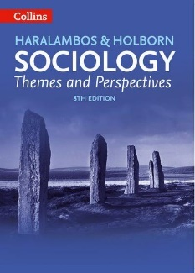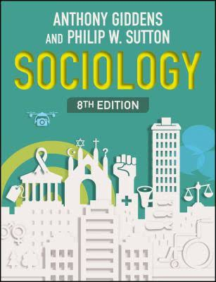

You will also be provided with a copy of AQA A Level Sociology Book One Including AS Level Book one 3rd Revised edition.
